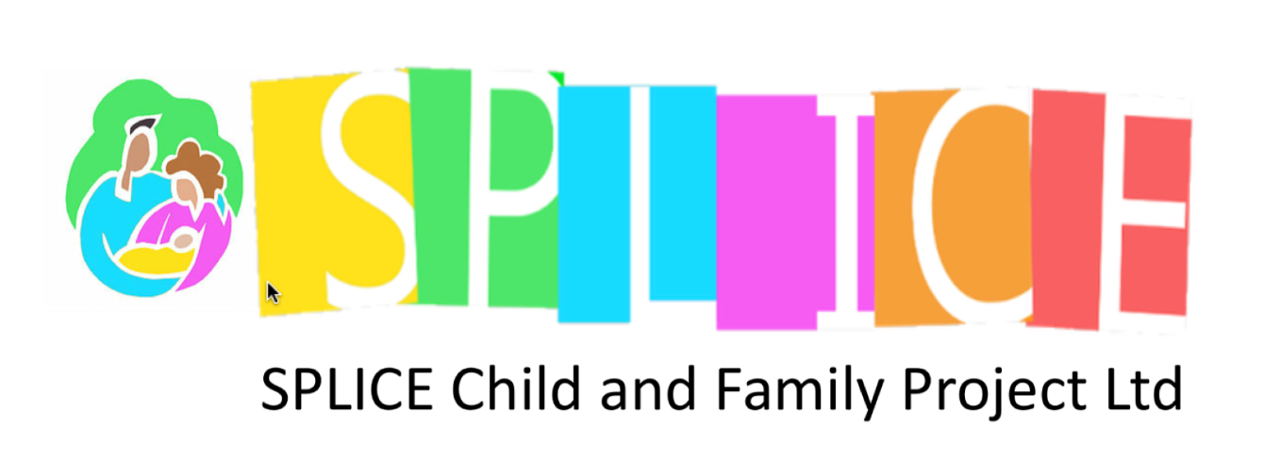
Community Based Centre,
North Avenue,
Pyle/Kenfig Hill. CF33 6ND
Telephone No: 01656 743733
E Mail : splice_childandfamily@yahoo.co.uk
www.spliceproject.co.uk
Company No 5828426 Registered Charity No 1125468

Wider Community Consultation
Our Place, Our Future
Splice Child and Family Project is looking at securing our current building as a permanent community base and increasing our public opening from three days to five days each week. As part of our National Lottery Community Fund application, we want to hear from the wider community, including people who may not currently use Splice. Your views will help us understand local needs and shape how our services develop.

1. Before today, had you heard of Splice Child and Family Project?
☐ Yes ☐ No
2. Do you currently use any Splice services?
☐ Yes ☐ No ☐ Not personally, but I know someone who does
3. Splice currently provides family activities, a Baby Bank, Community Pantry, community garden and practical support. Are there any other activities, services or support you feel are needed locally?
________________________________________________________________________________
________________________________________________________________________________
4. Thinking about the services above and the needs of people living locally, what do you think are some of the main challenges facing families and the wider community at the moment?
________________________________________________________________________________
________________________________________________________________________________
5. Splice is currently open to the public three days a week and plans to increase this to five days. Do you think having a community organisation like Splice available more often would be useful?
☐ Yes ☐ No ☐ Not sure
Please tell us why:
________________________________________________________________________________
________________________________________________________________________________
6. Splice is hoping to secure its current building as a permanent community base. What difference, if any, do you think having a permanent local base could make to the wider community?
________________________________________________________________________________
________________________________________________________________________________
7. Is there anything else you would like to tell us about what our community needs or how Splice could support local people in the future?
________________________________________________________________________________
________________________________________________________________________________
Thank you for taking the time to share your views with us.

