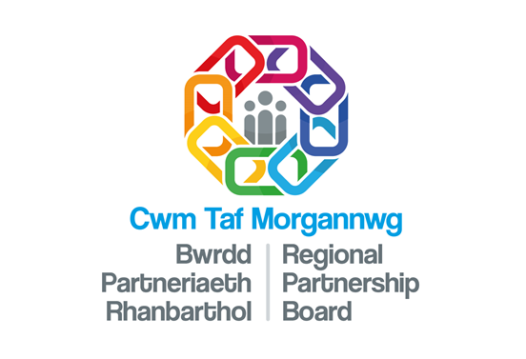 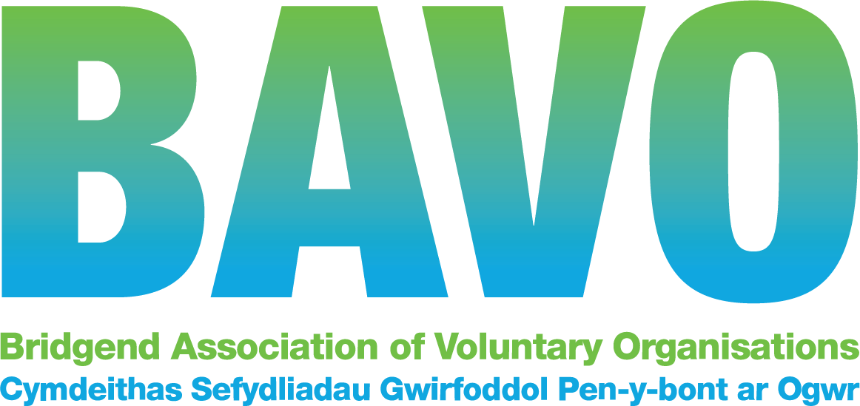

Navigator Introduction Form

**Please return completed form via email to E: communitynavigator@bavo.org.uk**

**or by post: Community Navigator - BAVO, 112/113 Commercial Street, Maesteg, CF34 9DL**

|  |
| --- |
| Title: …………….. Referral date: ….....………… Consent given: Y / N  Name: …………………………………………………………………………………….  Address: …..................................………………………………………………………………………………………………  ……………………………………………………………………………….. Postcode: ……………………..  Daytime Tel no: …………………...............……………… Welsh speaker: YES/NO  Date of birth: ….…………………….. Next of kin & contact no: ...........................……………………………  Is it OK for BAVO to pass your name, address and telephone number onto organisations that you have agreed can contact you with support? Yes  No  |
|  |
| **Occupancy**  Lives alone □ Lives with partner □ Lives with other □ |
| Gender |
| Employment Status  Employed □ Unemployed □ Retired □ Volunteering □ Unable to work due to illness □ Carer □ |
| Age or age group    18-39 □ 40-59 □ 60-69 □ 70 -79 □ 80+ □ |
| Reason for introduction |
| Any relevant health issues |
| Any risks or issues to be aware of if making a home visit |

|  |  |
| --- | --- |
| **Introducers’ source:** | |
| **Name and role** |  |
| **Tel no** |  |
| **Email** |  |
| **Relationship to person** |  |
| **If you are referring someone to the service, do you have their permission for us to contact with them? YES/NO** | |

|  |
| --- |
| **General Data Protection Regulation – GDPR**  BAVO takes your privacy seriously, and operates in line with GDPR (General Data Protection Regulation). We are processing your personal data on the legal basis of legitimate interest. Your name and contact details along with anonymised sensitive data where you have provided it, is used  (i) to register you as a service user on our system (ii) forward your details name, address, telephone number and email to the organisations you have selected to support or provide you with information and (iii) to manage our ongoing relationship with you and to track progress where appropriate.  We also provide anonymised statistics to our funders for equality and diversity monitoring purposes where they have been provided.  Your information may be passed to our funders as part of our audit and performance evidence and will be securely stored for up to three years. Full information including your rights, can be found on our Privacy Notice which can be provided on request or email dpofficer@bavo.org.uk |

**I understand and have permission to share this information with BAVO.**

Client Signature_________________________________ Date: _______________

**Where relevant:**

Signature (Referral agent) _____________________ Date:________________

**Please return completed form via email to E:** [**communitynavigator@bavo.org.uk**](mailto:communitynavigator@bavo.org.uk)

**or by post to: Community Navigator - BAVO, 112/113 Commercial Street, Maesteg, CF34 9DL**

BAVO Company no: 07691764 **•** BAVO Charity registration no: 1146543