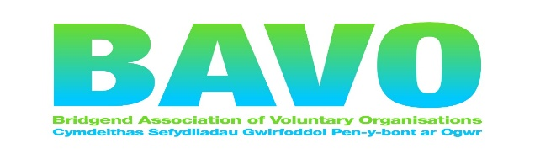

Bridgend ‘Unsung Heroes’ Awards 2024
Nomination form
Details about you, the nominator:

Name:_____________________________________________________________

Address:____________________________________________________________

________________________ Postcode:_________________________________

Tel:_______________________________________________________________

Email: ____________________________________________________________

Details of person/group you are nominating:

Name:_______________________________Group_______________________

Address:_______________________________________________________________

__________________________ Postcode____________________________________

Email_________________________________________________________________

Award category nominated for (tick one category only):

YOUNG VOLUNTEER

ADULT VOLUNTEER

COMMUNITY/CHARITY GROUP

SPORTS VOLUNTEER

OUTSTANDING VOLUNTEER

TRUSTEE

EQUALITY, DIVERSITY and INCLUSIVE CHAMPIONS

Reason for nomination:
Why do you feel this person deserves an award? Please put as much information as succinctly possible. Please use no more than 300 words.

I confirm that the information I have given is correct to the best of my knowledge. I have read and agree to abide by the rules of the scheme.
Signed_______________________________________Dated________________
Electronic signature is sufficient.

Nomination rules are as follows:

- Nominations must be received by 12 noon on Thursday 11TH April 2024.

- The individual (or group where appropriate) must reside within Bridgend County Borough.

- The individual/group (where appropriate) must carry out its voluntary work within Bridgend County Borough.

- Individuals cannot nominate themselves or be nominated by a family member.

- Nominators are asked to ensure that the nominee is aware and agreeable to the nomination being put forward.

- The judging panel’s decision is final.

Postal nominations must be marked ‘Private and confidential’ and should be returned to Sharon Headon, BAVO – 112/113 Commercial Street, Maesteg, Bridgend, CF34 9DL.

Electronic versions should be emailed to volunteering@bavo.org.uk

To obtain further copies of the nomination form, information and rules, call BAVO’S Bridgend Volunteer Centre, T: 01656 810400 or download the forms from our volunteering section of www.bavo.org.uk

