Trusted Assessor Role Cwm Taf Morgannwg wide

PROVIDER BRIEF

About Regional Partnership Boards (RPB)
Regional Partnership Boards have been established as part of the Social Services and Wellbeing (Wales) Act to improve health and social care. There are seven RPBs across Wales, and they bring together partners working in health, social care, the third sector, education, housing, the independent sector and people with lived experiences. Each RPB is responsible for developing a Population Needs Assessment, a Market Stability Report and a Regional Area Plan, to ensure partners are effectively working together with communities to meet their needs.

Purpose of the pilot
The aim of implementation of the trusted assessor role in CTM is to support and facilitate discharges from hospital to local services through Discharge to Recover then Assess (D2RA) pathways, especially pathways 0 and 1.
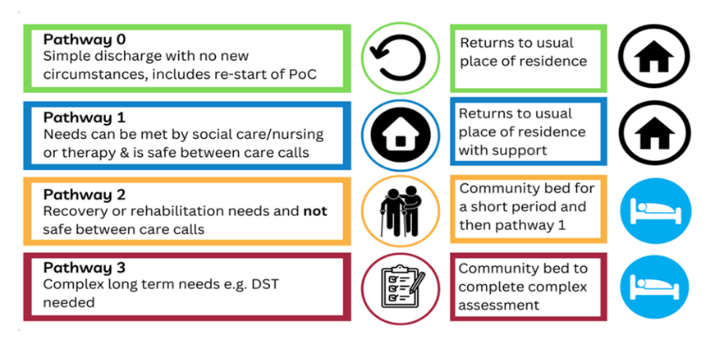

The main objective of the role is to reduce assessment delays in hospital discharge. The data below profiles the number of discharge delays in CTM and their reason; with assessment consistently being the number one cause of delay.
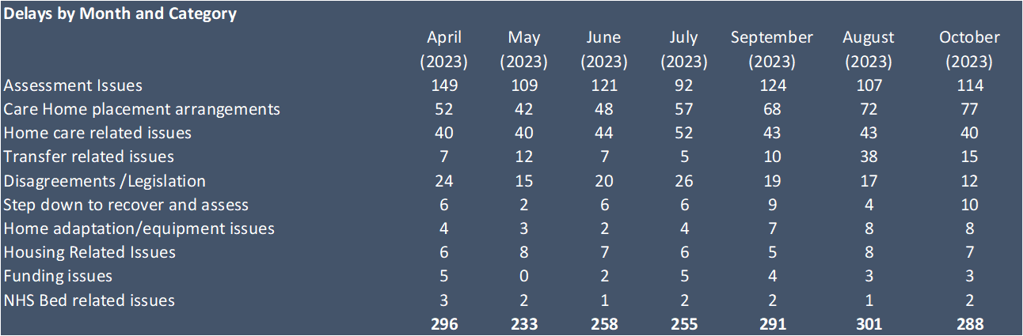
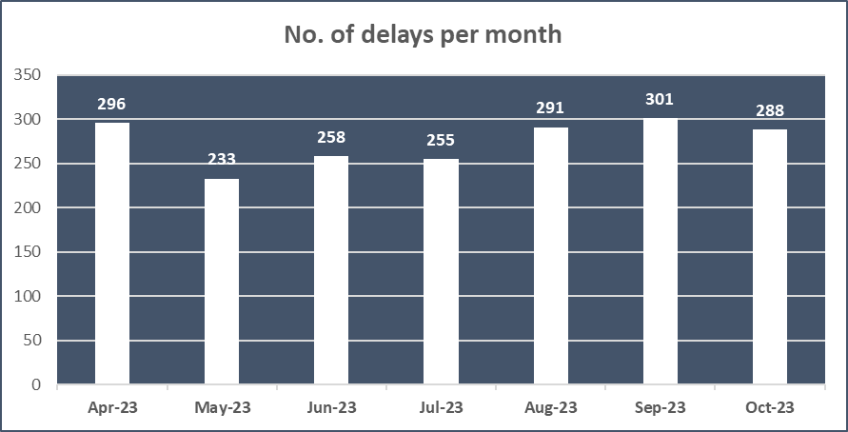

The role will support ward staff, discharge teams, patients and their families by co-ordinating and facilitating proportionate assessments through a transfer of care process. The aim is to free up resources in providers, facilitate discharges from hospital more quickly and smoothly and reduce post-admission problems and potential re-admissions to hospital.
Trusted assessment schemes do not remove or replace statutory responsibilities. It is essential that those who are placing their trust in others to undertake assessment on their behalf are confident that the risks, costs and local market are sufficiently understood, and that assessors are sufficiently skilled. It is imperative that there is a clear and rapid route for challenge, escalation and resolution of problems or issues raised by any parties involved in the trusted assessment scheme.
An Electronic Transfer of Care Document (E-Toc) was created as a proportionate and integrated assessment for discharge onto a D2RA pathway. It aims to reduce the number of separate assessments and is part of the E-Whiteboard list view, which updates key data for discharge and identified blocks to discharge (delays) that can be accessed and viewed by all partners.
The role will need to develop relationships within, and work alongside, partners and people involved in discharge planning; remaining focused on the outcome for the person.
This is an exciting opportunity to shape this new role to meet the needs of patients and discharge teams and deliver positive change by working alongside statutory agencies.
The Service provider will be expected to vigorously evaluate the role and adhere to the Regional Commissioning Unit’s (RCU) RIF performance framework a copy of which is available on request.
Further information on the requirements of the project can be found in the specification detailed in Appendix A.
Next steps
Please share your expression of interest, including information about your organisation and previous experience of delivering similar roles, a brief outline on how you will deliver the role and time scale for implementation, and what resources are required to deliver on the outcomes outlined within the specification in Appendix A.
We will need to receive this by the 5 January 2024.
Contacts:
Julia Wilkinson Julia.Wilkinson1@wales.nhs.uk
Sarah Mills Sarah.Mills@rctcbc.gov.uk

Appendix A: Specification

SPECIFICATION OF REQUIREMENTS:
Trusted Assessor

- Introduction

  - We are looking to enter an arrangement with a provider to deliver the trusted assessor role.

  - The agreement will be until 31st March 2025.

- Scope of the Requirement

2.1 The primary responsibility of the Trusted Assessors is to reduce assessment delays and support effective hospital discharge by co-ordinating proportionate assessments and facilitating transfer of patients onto the right D2RA pathway.

2.2 The trusted assessor role will work proactively with Ward staff, discharge teams, patients and their families by co-ordinating and facilitating proportionate assessments through a transfer of care process.

2.3 Trusted Assessors will deliver an asset based approach to support and provide practical support to unblock delays to discharge, which may also involve with referral to third sector and community provision
2.4 Utilise the Electronic Transfer of Care (E-Toc) assessment documentation and support its further development to support implementation.

2.5 The service provider will be expected to identify and evaluate success of the project. This must include strengths, weaknesses opportunities and pitfalls in the model for consideration

- The Requirement

The service will be required to deliver the role of the trusted assessor across three areas for a pilot period of approximately 15 months (until 31st March 2025) in line with the Job description included in Appendix B.

There is an expectation of two workers per acute site (6 in total). The volume of referrals are expected to be around 25 per week.

Alongside this delivery the provider will also have to evidence consideration of the following when applying for this funding opportunity:

- If an organisation is already delivering discharge support roles they must be clear in their specification how the Trusted Assessor will be delivered alongside these existing roles not as a replacement to them
- If an organisation is already providing discharge support roles they must outline how this will support the trusted assessment process.
- The organisation must also clarify how staff working with different role expectations will support the same client group without causing confusion to the individual being supported
- The Trusted Assessor role must be neutral
- Training provided to the trusted assessor must be in line with national requirements
- There will need to be a consistent approach across the region to ensure parity of outcomes for individuals in the pilot areas
- Consideration must be given as to how the individuals supported should the pilot not continue
- When bidding, organisations must outline plans for cover for leave and budget for training

- Outcomes and Deliverables
4.1 The service will adhere to the regional commissioning unit’s outcomes framework for all RIF funded services. They will also be expected to complete qualitative project evaluations and any other reporting requirement as requested by Welsh Government.

- Timescales

5.1 The initial funding for these roles will be until 31st March 2025.

- Working arrangements

6.1 The successful applicant will provide performance updates on a regular basis to the Regional Commissioning Unit and Integrated Discharge Board as required.

6.2 The trusted assessor will be embedded within the wards and will support delivery against other areas outlined within the job description (appendix B)

- Service Levels and Performance

7.1 The successful applicant will be expected to report to the Integrated Discharge Board and other stakeholders on a regular basis. These updates will include:

- Number of referrals
- Number of individuals supported
- Numbers of EToCs (Electronic Transfer of Care Documents) supported.
- Number of EToCs received by discharge hub within time target (48 hrs prior to EDD/Clinical Optimisation)
- Numbers referred to alternative support (e.g. third sector / telecare).
- Numbers supported to return home, usual place of residence.
- Number of assessment delays recorded on EWBs

7.2 CTM is committed to coproduction with people with a lived experience on equal footing to paid professionals. We expect this role to engage, involve and coproduce support with people and their loved ones offering voice choice and control to its referees

- Pricing

8.1 Provider to submit total costs to deliver the contract.

- Payment

  - The Provider will be paid quarterly in arrears via a PO. The Provider must invoice after a PO is raised. The PO must be stated on every invoice due to the new NO PO NO PAY policy. Invoices must be sent to the Regional Commissioning Team. A contact will be provided to the successful applicant.

- Location

10.1 The trusted assessor role will be delivered across the DHG sites of Prince Charles Hospital (PCH), Royal Glamorgan Hospital (RGH) and Princes of Wales hospital (POW).

10.2 The trusted assessor will receive referrals from a number of sources within health and social care to assist discharge in support of the D2RA pathways.

Appendix B: Trusted Assessor Job Description
The aim of implementation of the trusted assessor role in CTM is to support and facilitate discharges from hospital to local services through Discharge to Recover then Assess (D2RA) pathways, especially pathways 0 and 1.
The main objective of the role is to reduce assessment delays in hospital discharge. And the purpose of this role is to support ward staff, discharge teams, patients and their families by co-ordinating and facilitating proportionate assessments through a transfer of care process. The aim is to free up resources in providers, facilitate discharges from hospital more quickly and smoothly and reduce post-admission problems and potential re-admissions to hospital.
The role will need to develop relationships within, and work alongside, partners and people involved in discharge planning; remaining focused on the outcome for the person.
This is an exciting opportunity for the to shape this new role to meet the needs of patients and discharge teams and deliver positive change by working alongside statutory agencies
For more information please see the associated Role Descriptions and Person Specifications.

Job Description and Person Specification

Job Purpose
The primary responsibility of the Trusted Assessors is to support effective hospital discharge by co-ordinating assessments and facilitating the transfer of patients on the right D2RA pathway and reducing assessment delays to discharge.

Function
- Co-ornate and carry out transfer of care assessments of patients across CTM, including re-started packages of care (D2RA pathway 0).
- Act as a point of liaison for discharge teams, patients and their families, and providers by ensuring information is shared with appropriate parties in relation to potential discharges into care settings, and work to facilitate the flow of information between the hospital, Adult Social Care and the Discharge team about the person’s needs and community services’ ability to meet those needs.
- Provide information and support to patients and to their families during the discharge process.
- Ensure that data and information systems are accurate and up to date and contribution to reporting requirements associated with discharge delay.
- Support improvements in discharge arrangements to people’s home environment, improving patient experience, safety and patient flow including ensuring support requirements are in place to enable safe hospital discharge and D2RA pathway admission.
- Complete accurate and timely collection, analysis and reporting of data relating to discharges from hospital to ensure that the work can be properly evaluated.
- Identify bottlenecks in processes and implement solutions to aid in reducing pathway of care delays, adhering to the principles of continuous improvement.
- Work flexibly and there may be a requirement for some weekend working.
- Have an ability to travel across CTM, on occasion transporting patients, carers or colleagues as appropriate.
- A satisfactory DBS disclosure at the enhanced level is required.
- Ensure that alternatives to pathway 1 support have been explored such as third sector support, telecare or equipment, and use the strengths-based approach, focusing on encouraging independence.
- The above list of duties is indicative only and not exhaustive. The job holder will be expected to perform all such additional duties as are reasonably commensurate with the role.

Person Specification

ESSENTIAL | DESIRABLE
- Experience of working as part of multi-disciplinary and multi-organisational teams.  - Experience of working in health and social care or third sector services with this target group.  - Substantial experience of working with older peoples’ services / disability | - Experience of care services management. Involvement in discharge processes in a variety of settings.  - Understanding of the process of assessing people’s needs from a Hospital setting.  - Understanding of a regulated work environment.
SKILLS AND ABILITIES
- Good organisational skills, with the ability to work under pressure to meet deadlines and targets.  - Enthusiasm to take on a new role and shape the job to fit the need.  - Able to work effectively in situations that present challenges.  - Excellent communication skills, including good oral and written communication skills.  - The ability to motivate other professionals to meet person-centred outcomes for individuals and families.  - Able to see a situation from the perspective of all of the people involved. | - Able to manage change and to be highly adaptable.  - Kind and empathic.  - Able to work alone, but also to be part of a team.  - Experience of using hospital systems and LA MIS systems.
- Polite, honest, reliable, professional and able to build trusting relationships and overcome scepticism or other work culture challenges.
- Problem solving ability including working innovatively.
- The ability to use IT equipment effectively and undertake a range of admin tasks.
EDUCATION/ QUALIFICATIONS/ KNOWLEDGE
- Knowledge of a range of clinical/social care/wellbeing assessment tools  - Level 4 QCF in health and/or social care or equivalent experience  - Knowledge of issues related to the client group. | - Good working knowledge of regulations and of relevant legislation, e.g. Social Services and Wellbeing Act Wales (2014), Mental Capacity Act etc  - Current Social work/care registration.  - AHP registration.
OTHER REQUIREMENTS
- Flexible approach to work by responding to the needs of the role. | - Evidence of own continuous personal and professional development.
- Commitment to continuous personal and professional development.  - Commitment to OACP policies and patient’s expectations in areas such as Equal Opportunities and Data Protection.  - Commitment to quality care and support for all patients.  - Driver’s licence and access to a car. | - Evidence of having completed training in equality and diversity awareness.

