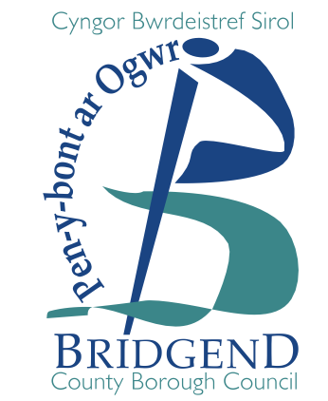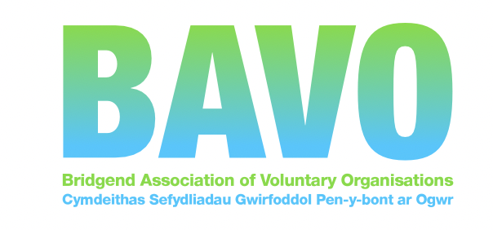

Haf o Hwyl 2022 /Summer of Fun 2022 Deadline 24th June 2022 at 2pm

Providing play, leisure, recreational, sporting, cultural activities for children and young people in Bridgend County Borough
We want to support our children and young people by providing the space and time for free activities this summer by:
- creating space and opportunity for free summer fun activities
- supporting children and young people's enjoyment and fun through offering opportunities to express themselves through such activities;
- community based interactive, creative and play/fun-based initiatives for all ages;
- providing opportunities to play and/or take part in activities with friends and peers;

The Summer of Fun programme aims to provide all children and young people aged 0 – 25, with the opportunity to access free activities in addition to regulated childcare provision (not instead of).

Successful projects will support the social, emotional, physical and mental wellbeing of all children and young people, including tackling social isolation and further developing young people’s confidence to re-engage with each other and with wider society.

Things to note:
Grants for playscheme/youth provision can be up to £750 to add value to any existing plans you may have. This is revenue funding only; small amounts of consumables may be considered (e.g. arts/crafts), but food is not eligible. The funding can be used for provision on weekdays or weekends, held during the day or in the evenings.

The timetable for the Summer of Fun provision can be from 1 July 2021 but activity MUST be completed by 30 September 2022.

Terms: On completion of the activity, successful applicants will need to provide details on what they have offered and where; the amount of sessions run; the numbers and ages of children and young people that have been engaged and where activities have taken place as well as an expenditure form. This will need to be completed fairly quickly after 30th September. Welsh Government may also be keen to talk to providers on what has worked well and what can be improved.

If you have received a grant previously and not submitted all required returns, unfortunately you will not be eligible to apply until your previous grant conditions have been complied with. Our team can help with this.

If you need help to apply, please contact us. Before submitting your form, please rename it with your groups name.

SECTION 1: Your organisation

Name of organisation / group / project:
Name of main contact/ Project lead:
Contact address and postcode:
Contact telephone no:
Contact e-mail address:
Are you a BAVO member?

SECTION 2: ELIGIBILITY CRITERIA
Please confirm that your organisation/ group/ project:
Is a third/voluntary sector (not for profit) organisation and is independent of government, private and public sectors: | Yes / No
Type of group | Registration number
- Constituted group;
- Registered Charity
- Trust
- Community Interest Company (CIC);
- Company limited by guarantee (not for profit);
- Industrial and Provident Society (IPS);
- Financial Mutual.
Please confirm you will use the funding solely for Summer of Fun Activities in Bridgend County Borough? | Yes / No
Your organisation has at least two unrelated authorised signatories for each payment made from your account | Yes / No
Your organisation has its own bank account (in the name of the organisation) | Yes / No
In order to release funds quickly, please confirm:
Bank :
Organisation Account name:
Sort code:
Account number:

SECTION 3: PROJECT DETAILS
Up to £750.00 grants are available for work to be delivered in bridgend County Borough,they are revenue only, but small amounts of consumables may be possible to fund.
What activities are you planning to offer? Please tick
Sport
Play
recreation
Leisure
Cultural
Other (please state)

Please let us know if you intend to specifically offer any of the following...
Open access play work
Open access youth centre/provision
Out of school holiday provision
Duke of Edinburgh or other schemes
Cultural/arts & crafts provision
Sports activity
Other (please state)

Provide brief details of your proposed summer of fun ideas.

Do you have any experience of running similar opportunities?
Tell us how many children and young people you aim to help, and their age range. (If funded, you will need to capture this data for us)

How many Children/young people you aim to attract to your activities?
Their age ranges?
Where will you deliver these activities, i.e. which area of the County? Outdoors/indoors? Name of venue?
Where?
Open space/ park/ forest
Community space/centre
Sports facility
Leisure centre
Town Hall
Library
School/nursery
Our own premises
Other (please specify)

When will your activities run?
Summer school holiday only
Throughout July – September 30th
Other (please specify)

Please tell us how much money you are applying for? Give us detail.
You will be required to provide a post-project list of expenditure and submit to BAVO
Eg. Salaries (break down), volunteer expenses, venue hire
Are you working with any partners on this activity? If so please tell us who.
Are you planning to offer this activity through the medium of …
Please tick
English Only
Welsh Only
Bilingually
How will you promote and raise awareness of the activity? e.g. Social media, existing service users/ via school etc.
We encourage you to share details of your planned activities via BCBC and BAVO social media

Do you have a safeguarding policy and lead person?
YES |  |  |  |  | NO
If no, please be advised you will need to contact BAVO to ensure you are compliant.
PLEASE NOTE:
- If an award in principle is made, and you are not a member of BAVO or we do not hold an up-to-date copy of your governing document on file, you will be required to complete a membership form and send your governing document for our records.
- If successful we will also need a copy of your safeguarding policy (we can help with this)
- You will be provided with a link to provide data and information about your project to WG. You will need to send your expenditure form to BAVO on completion
- All activities will need to be notified to BAVO so that they can be promoted widely.
SECTION 4: DATA PROTECTION AND DECLARATION
⬜ |  | We, the above-named Organisation confirm that we have read the application guidelines and our application is an eligible project.
DATA PROTECTION
Data Protection (GDPR) Act 2018. The information given will be entered and processed by BAVO, application forms will also be kept. The information will be used by BAVO for administration purposes of the grant scheme and for the monitoring and promotion of the voluntary sector in BAVO. Personal data is limited to contact names, position, address, telephone and other contact numbers, organisation and project; it may be considered as sensitive personal data where the organisation/project is involved with matters relating to race, ethnic origins, politics, religions or similar beliefs, physical, mental health or sexual life, but BAVO would only receive anonymised data in that respect.

All of the information you provide us with will be held on our IT system. This information will be used for the administration of applications and grants and for producing statistics and for audit purposes and reporting as a legal requirement of BAVO distributing public funding on behalf of Welsh Government, BCBC or others. Copies of this information will be provided, when necessary to individuals and organisations that BAVO consults with when assessing applications and grants, and to originating funders.

Contact details will only be disclosed to third parties for the following purposes: to enable BAVO to process your application; to enable BAVO and funders to monitor funding. Your information will be shared with BCBC and Welsh Government as the originating funders.

The organisation’s details may also be used to announce successful projects, and to promote the awarding grant bodies and the grant scheme generally via press releases and other bona fide promotional activities including placement on BAVO’s website and other BAVO publications.

Financial data is kept for up to 7 years on a legal basis around audit requirements of public funds.

By completing the declaration and emailing us this form, you agree to BAVO using your data in this way.
⬜ | Please tick if you wish for BAVO to help you promote and register your organisation on infoengine.cymru
⬜ | Please tick if you wish to join / rejoin BAVO (a membership form will be sent for new members)
DECLARATION
We the above named organisation understand that by accepting a grant from BAVO we agree to only use it for the purposes stated on this form.
Applicant’s name
Role in organisation
Date:

We are currently not able to accept applications in the post. If this causes you a problem please call us.

It is YOUR responsibility to check your application has been received.

If you do not receive an acknowledgement your application has likely not been received on email and will not be considered. If you do not receive an acknowledgment within 2 working days, please call us on 01656 810400 to check receipt.

Grant awards will be notified 1st week July 2022

Please return the completed application by email to:
Grantsadmin@bavo.org.uk

Applications to be submitted by 24th June 2022 at 2pm or earlier
Please remember to keep a copy for your records.

