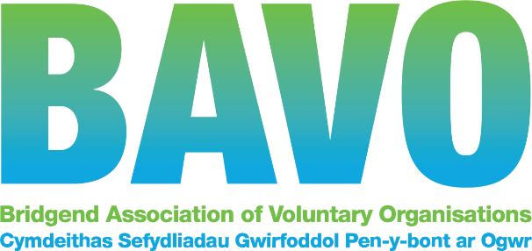

JOB DESCRIPTION
Job Title: | Mental Health Service User Involvement Officer
Responsible to: | Operations and Partnerships Manager
Hours: | 37 per week Fixed term to 31/3/2023 subject to ongoing funding
Salary: | £ 25,481 pa
Pension: | 8% non contributory
Annual Leave: | 25 days plus up to 8 Bank Holidays (pro rata where applicable)
Location: | Head office, Maesteg  We are currently trialing a hybrid model of working which includes office, home and community working.  The place of work may change due to relocation or other reason.
Other | We are committed to supporting workforce wellbeing, and encouraging diversity in our workforce. We are proud to have achieved the Small Healthy Workplace Gold Award.  BAVO offers an Employee Assistance Programme, opportunities for personal development, Holiday buy/sell scheme, and reduced HALO gym membership cost (corporate rate apply).

About BAVO
Our mission is to support, promote, empower and upskill third sector organisations so that they are effective and efficient, informed and influential and can make a positive impact on people’s lives. We connect people to groups and to one another so that they may play an active and positive role in their communities.

As the umbrella body for third sector organisations within Bridgend County Borough, BAVO offers support, information, advice and training to all voluntary and community groups and social enterprises operating within the county. We are a small team of about 20 people, but have over 400 member organisations, and we support third sector, voluntary and community providers and services.

We are supported by Welsh Government, Bridgend County Borough Council and the Cwm Taf Morgannwg University Health Board, and these relationships are vitally important to us.

Our Health Partnerships team supports and engages with those who have a role in providing health and wellbeing services. We network organisations together, assist collaboration and help members develop and grow their service provision to meet local needs. We give guidance, support and facilitate our members participation in strategic meetings and decision making processes, and we are a conduit for information flow.

BAVO, along with other County Voluntary Councils (CVC) in Wales and Wales Council for Voluntary Action, form a national network known as Third Sector Support Wales (TSSW). https://thirdsectorsupport.wales
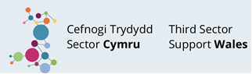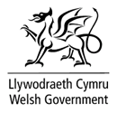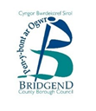

Introduction : The Role
Summary Job purpose:

To lead on the involvement of people and relevant others, such as unpaid carers / relevant family members, who are receiving or who have recently received mental health services, working with partners in the public and third sector to co-design mental health services.

The role will promote partnership working to contribute to local and regional plans to improve wellbeing through:
- Supporting mental health service users and those with lived experience to work together to identify gaps in support and take advantage of opportunities to develop new services for people of all ages.
- Facilitating partnership working through the involvement of service users and those with lived experience of mental health issues in informing the design, planning, implementation and evaluation of services.
- Add value to the core Influencing and Engagement work of BAVO and connect to our wider Healthy partnerships and resourceful communities programmes.

Main tasks

To engage with service users, unpaid carers and relevant family members in working with public and third sector partners to:

- Provide specialist information, guidance and support about service user involvement.
- Increase the range of service user involvement opportunities available to service users locally, regionally and nationally.
- Ensure that service users and those with lived experience have the support and mechanisms to contribute to improving local mental health services.
- Support and contribute to the work of the Cwm Taf Morgannwg ‘Together for Mental Health’ Partnership Board.
- Review, develop and maintain partnership resources to support the development of good practice in service user involvement.
- Work with partners and stakeholders to develop and promote opportunities to involve more service users, learn from their experiences and improve services through co-production.
- Promote and implement effective equality, diversity and inclusion to ensure opportunities are open to all.
- Produce high quality reporting and key performance indicators of service user involvement activities and keep accurate and up to date records.
- Work effectively locally and regionally with colleagues internally and regionally with CVC colleagues in relation to peer support, service user involvement and mental health support.
- Work effectively with relevant individuals connected with Cwm Taf Morgannwg University Health Board Integrated Locality and System Groups and relevant work streams.

Detailed Responsibilities
- Support the delivery of a comprehensive range of service user involvement opportunities and mechanisms.
  - Facilitate and actively promote a programme of service user involvement activities and opportunities which serves to enhance a service user’s experience and wellbeing.
  - Support service users to have their voices heard, facilitating their involvement in co-production, for example, supporting them in their representative roles, attending relevant partnership and planning meetings, and interview panels.
  - Develop and promote opportunities and platforms to provide feedback on mental health services.
  - Support service user learning and development and access to relevant courses, events and meetings.
  - Identify and build working relationships with relevant agencies, with an aim to provide opportunities for service users.
  - Coproduce informative and effective literature to promote service user involvement.
  - Ensure quality support is offered to service users including both one to one and group support.
  - Attend forums, meetings and networking events as required.
  - Facilitate meetings and mechanisms for service user involvement.
  - Ensure that service users are equipped with the training and skills needed to deliver their respective roles.

- To produce high quality reporting and key performance indicators of service user involvement activities.
  - Define, implement and manage all monitoring and evaluation of the programme systematically and in line with funder requirements
  - Collect relevant data for the key performance indicators as required, and review these to monitor and shape service delivery.
  - Identifying case studies and success stories to illustrate outcomes.
  - Provide regular reports and updates on the service user involvement programme as requested.
  - Actively participate in our organisations internal staff meetings, training, supervision and wider organisational activities as requested.

This is a lead role and will take additional responsibility for:
- Organising regular on-line regional meetings with similar role holders in our fellow organisations VAMT and Interlink to supporting effective and regular communication and share information and practice.
- Ensuring a consistent and joined-up approach across CVC’s to contributing and attending regional meetings and related activities
- Developing a process to agree a shared ‘delivery plan’ and relevant monitoring and evaluation reporting arrangements (please refer to points 5 and 6 below).
- Agreeing communication processes with service users / carers / community and voluntary organisations and other partners.
- Acting as the regional contact and agreeing communication channels with the relevant contact in Cwm Taf Morgannwg University Health Board (CTMUHB).
- Collating reports from fellow CVC’s and bringing together where appropriate
- Managing and supervision of relevant Healthy partnerships staff within BAVO

3. Additional
- Promote the importance of best practice and quality standards in volunteer involving organisations;
- Be prepared to work during evenings and weekends from time to time for which TOIL (time off in lieu) will be granted;
- Work within the framework of BAVO’s policies, procedures and plans;
- All employees have a responsibility for their own health and safety whilst at BAVO’s premises including work colleagues and members of the public in accordance with safety legislation and BAVO’s health and safety policy;
- Undertake relevant training;
- Contribute to BAVO events and annual reports
- Any other duty that fits within the framework of this role or BAVOs’ services.

BAVO undertakes substantial community development activity and all staff are required to carry out their duties to support and promote capacity building within the sector. The role requires a positive attitude and approach and needs to embrace a team working environment. The post holder will follow our values and behaviours framework in all that they do.

The nature of this role will require the post holder to undertake an enhanced DBS check. BAVO can only employ people who are entitled to work in the UK

v4.09/21

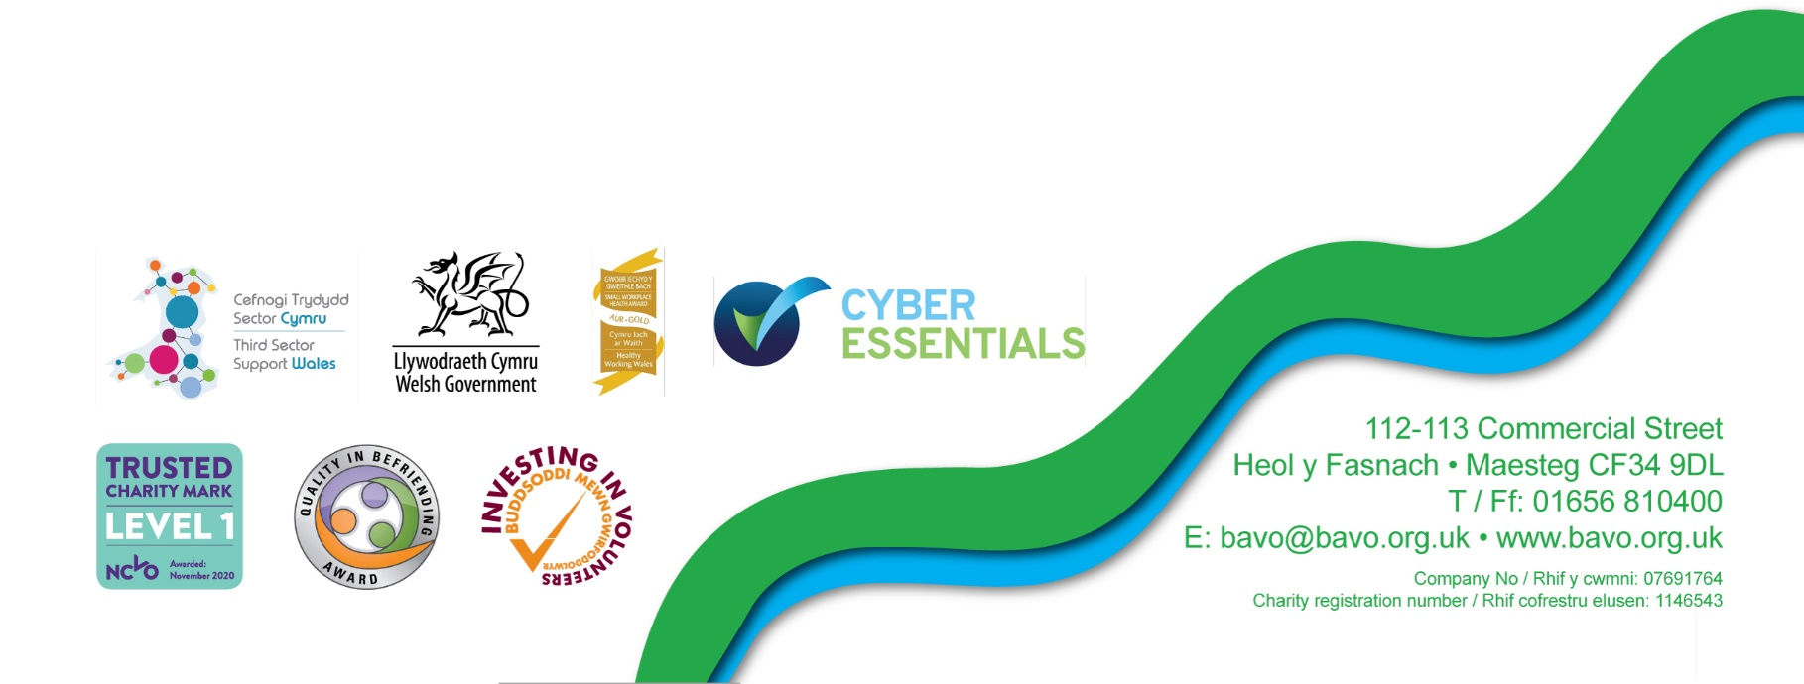
PERSON SPECIFICATION
Essential and desirable skills, abilities, experience, knowledge and special requirements for the post. This form also indicates how the different requirements may be assessed during the selection process: A = Application form, I = Interview

 | Essential | Desirable | Method of assessment  A I
Personal experience of using mental health services, past or present, and ability to use this experience positively |  | ✓ | ✓
A good understanding of the wide range of issues facing people with mental health needs | ✓ |  | ✓ | ✓
Experience of facilitating groups and partnerships taking a collaborative and caring approach | ✓
Experience of working in or with the third sector |  | ✓ | ✓
Knowledge and understanding of quality assurance and best practice in principles and practice |  | ✓ | ✓
Experience of developing good working relationships with a wide range of stakeholders |  | ✓ | ✓
Ability to constructively challenge language and practice while maintaining good working relationships | ✓ |  | ✓ | ✓
Experience of involving service users in their own support | ✓
Good administration skills, including minute taking |  | ✓ | ✓
Excellent written and verbal communication skills | ✓ |  | ✓ | ✓
Ability to design and deliver presentations and training |  | ✓ | ✓ | ✓
Ability to work as part of a team | ✓ |  | ✓ | ✓
The ability to work on own initiative and adapt work plans at short notice to meet any unexpected needs of the project | ✓ |  | ✓ | ✓
Good time management skills and ability to prioritise own workload - Highly organised working methods | ✓ |  | ✓ | ✓
Experience of and ability to use spreadsheets, email and word, preferably Microsoft Office /365 | ✓ |  | ✓ | ✓
The ability to be flexible and willing to work unsocial hours to meet the needs of the project | ✓ |  | ✓ | ✓
Ability to drive / access to a car for travel across Cwm Taf Morgannwg (RCT, Merthyr and Bridgend) | ✓ |  |  | ✓
A commitment to equality, diversity and inclusion and how to apply this in practice | ✓ |  | ✓ | ✓
Welsh Language skills |  | ✓ | ✓ | ✓

Our values and behaviours

Working with us gives you the opportunity to make a real difference to our local third sector, communities and in turn, the lives of the people of Bridgend County Borough. To succeed in this, we provide a framework for our culture that reflect the standards and conduct we expect from all our people.

Our Values
Our values are at the heart of everything we do, they reflect what we stand for and we truly believe they will help us achieve our vision to be the best we can be, and to provide the best services to create a flourishing, robust, trusted, influential and sustainable voluntary, community and not-for-profit sector in Bridgend county.

We are committed to creating a working environment of equality, respect, support and inclusion where everyone is valued, can thrive and contribute.

Our ambition is for everyone working at BAVO to embody our values, drive our behaviours and help us achieve our vision. Our values are to be:
- High performing: we continually improve through listening, learning and innovation to be excellent at what we do.
- Collaborative: we work partnership with others to achieve the best outcomes for our members, communities and the people they serve.
- Customer focused: We engage, involve and co-produce our activity and listen, learn and improve.
- Accountable: We take responsibility for our actions and delivery, and are answerable to our members, stakeholders and partners
- Trustworthy: We are honest, fair and speak up.

Our Behaviours

What do we mean by behaviour?
Behaviours are how we demonstrate the approach and attitude we want to take to work and how we demonstrate our values. They are the same for all employees and are about:

• how we do things • how we treat each other
- what we say and how we say it • how we expect to be treated

Our behaviours guide how we treat others, make our decisions and work on a day to day basis to improve our performance and the service to our members, funders and stakeholders.

Our behaviours mean that we:
- Do what we say
- Move with purpose and energy
- Focus on solutions
- Help people and communities to find their own solutions
- Build strong working relationships
- Are the best we can be

All staff are expected to follow our detailed framework.

