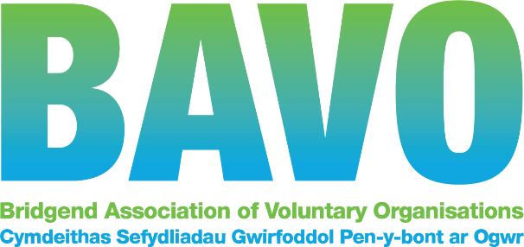

JOB DESCRIPTION

Job Title: | Mental Health Development Officer
Responsible to: | Operations and Partnerships Manager
Hours: | 37 per week Fixed term to 31/3/2023 subject to ongoing funding
Salary: | £ 24,012 pa
Pension: | 8% non contributory
Annual Leave: | 25 days plus up to 8 Bank Holidays (pro rata where applicable)
Location: | Head office, Maesteg  We are currently trialing a hybrid model of working which includes office, home and community working.  The place of work may change due to relocation or other reason.
Other | We are committed to supporting workforce wellbeing, and encouraging diversity in our workforce. We are proud to have achieved the Small Healthy Workplace Gold Award.  BAVO offers an Employee Assistance Programme, opportunities for persona development, Holiday buy/sell scheme, and reduced HALO gym membership cost (corporate rate apply).

About BAVO
Our mission is to support, promote, empower and upskill third sector organisations so that they are effective and efficient, informed and influential and can make a positive impact on people’s lives. We connect people to groups and to one another so that they may play an active and positive role in their communities.

As the umbrella body for third sector organisations within Bridgend County Borough, BAVO offers support, information, advice and training to all voluntary and community groups and social enterprises operating within the county. We are a small team of about 20 people, but have over 400 member organisations, and we support third sector, voluntary and community providers and services.

We are supported by Welsh Government, Bridgend County Borough Council and the Cwm Taf Morgannwg University Health Board, and these relationships are vitally important to us.

Our Health Partnerships team works to support engagement with those who have a role in providing health and wellbeing services . This includes funders, commissioners in health and local authorities, and third sector providers. We network organisations together, assist collaboration and help members develop and grow their service provision to meet local needs. We give guidance, support and facilitate our members participation in strategic meetings and decision making processes, and we are a conduit for information flow.

BAVO, along with other County Voluntary Councils (CVC) in Wales and Wales Council for Voluntary Action, form a national network known as Third Sector Support Wales (TSSW). https://thirdsectorsupport.wales
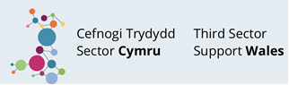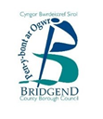

Introduction : The Role
Job purpose:
The role will promote partnership working to contribute to local and regional plans to improve wellbeing through:
- Supporting third sector organisations to work together to identify and address gaps and take advantage of opportunities to develop new services for people of all ages.
- Facilitating partnership working through the involvement of third sector organisations in the design, planning, implementation and evaluation of services.
- Connecting with stakeholders to support co-production and service development and improvements in line with healthy needs/population assessments
- Add value to the core Influencing and Engagement work of BAVO and connect to our wider Healthy partnerships and resourceful communities programmes.

Main tasks
- To work with Mental Health Service User Officer and the Healthy Partnerships team to ensure effective engagement with third sector providers
- Shape and provide information, guidance and support to third sector organisations including signposting to relevant services such as funding, development support and training.
- Ensure that third sector representatives and organisations have the support and mechanisms to contribute improving local and regional mental health services.
- Support and contribute to the work of the Cwm Taf Morgannwg Together for Mental Health Partnership Board and Health and local authority Mental Health service planning
- Work with partners to develop and promote collaborative and co-productive approaches and opportunities.
- Produce good quality reporting, monitoring and evaluation, keeping accurate and up to date records on key performance indicators in line with funder requirement.
- Promote the outcomes and impact of third sector services through evaluation reports, events, case studies and films.
- Work effectively locally and regionally with colleagues internally and externally with CVC colleagues in relation to peer support, service user involvement and mental health support.
- Work effectively with relevant individuals connected with Cwm Taf Morgannwg University Health Board and their teams.
- Any other duty / task required by the organisation, relevant with the post and/or in order to fulfil the business needs of the organisation or its members.

Detailed Responsibilities
- Support third sector organisations to work together to identify and address gaps and take advantage of opportunities to develop new services for people of all ages. Support third sector organisations to:
- Identify opportunities to innovate and develop new approaches, models and services by exchanging information and sharing best practice including organising regular seminars, network meetings and events.
- Identify opportunities for specialist mental health organisations to work with the wider third sector to improve mental health support in the wider community.
- Work together through local and regional forums and networks such as the Cwm Taf Morgannwg Mental Health Forum including helping to develop action plans and complete progress reports.
- Collaborate on of service developments and delivery including supporting feasibility studies and grant applications.
- To develop activities and services that respond to identified gaps within relevant plans and strategies.
- Provide relevant and up to date information, advice and assistance, for example, one to one support, e-briefings, websites and social media.
- Supporting the development of new and existing voluntary sector organisations.
- Organise and/or contribute to relevant consultation, policies and plans through coordinating network meetings, events, presentations and briefings.

- Facilitate partnership working through the involvement of third sector (voluntary, community and not-for-profit) organisations in the design, planning, implementation and evaluation of services, supporting partners to:
- Support third sector involvement and representation at relevant partnerships including the Cwm Taf Morgannwg Mental Health Partnership Board, Integrated Locality and Systems Groups and associated planning groups.
- Promoting best practice and sharing expertise across agencies and sectors work with commissioners in the statutory sector to promote new models and approaches.
- Address health inequalities and promote equality, diversity and inclusion.
- Support the production and updating of population needs assessments.

Additional
- Promote the importance of best practice and quality standards in volunteer involving organisations;
- Be prepared to work during evenings and weekends from time to time for which TOIL (time off in lieu) will be granted;
- Work within the framework of BAVO’s policies, procedures and plans;
- All employees have a responsibility for their own health and safety whilst at BAVO’s premises including work colleagues and members of the public in accordance with safety legislation and BAVO’s health and safety policy;
- Undertake relevant training;
- Any other duty that fits within the framework of this role or BAVOs’ services.

BAVO undertakes substantial community development activity and all staff are required to carry out their duties to support and promote capacity building within the sector.

The role requires a positive attitude and approach and needs to embrace a team working environment. The post holder will follow our values and behaviours framework in all that they do.

The nature of this role will require the post holder to undertake a DBS check at a basic level

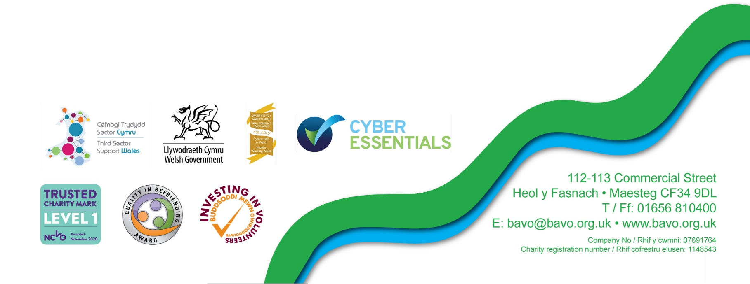
v4.09/21
PERSON SPECIFICATION
Essential and desirable skills, abilities, experience, knowledge and special requirements for the post.
This form also indicates how the different requirements may be assessed during the
selection process: A = Application form, I = Interview

 | Essential | Desirable | Method of assessment  A. I
A good understanding of the wide range of mental health and wellbeing issues. | ✓ |  | ✓
Experience of facilitating/supporting groups and partnerships | ✓ |  | ✓ | ✓
Experience of working in or with the third sector |  | ✓ | ✓
Knowledge and understanding of quality assurance and best practice in principles and practice |  | ✓ | ✓
Experience of developing good working relationships with a wide range of stakeholders |  | ✓ | ✓
Ability to constructively challenge while maintaining good working relationships | ✓ |  | ✓ | ✓
Good administration skills, including minute taking |  | ✓ | ✓
Excellent written and verbal communication skills | ✓ |  | ✓ | ✓
Ability to design and deliver presentations | ✓ |  | ✓ | ✓
Ability to design/lead and deliver workshops/training |  | ✓ | ✓
Ability to work as part of a team | ✓ |  | ✓ | ✓
The ability to work on own initiative and adapt work plans at short notice to meet any unexpected needs of the project | ✓ |  | ✓ | ✓
Highly organised working methods | ✓ |  | ✓ | ✓
Experience of and ability to use spreadsheets, email and word, preferably Microsoft Office /365 | ✓ |  | ✓ | ✓
The ability to be flexible and willing to work unsocial hours to meet the needs of the project | ✓ |  | ✓ | ✓
Ability to drive / access to a car for travel across Cwm Taf Morgannwg (RCT, Merthyr and Bridgend) | ✓ |  |  | ✓
A commitment to equality, diversity and inclusion and how to apply this in practice | ✓ |  | ✓ | ✓
Welsh Language skills |  | ✓ | ✓ | ✓
The above post is subject to appropriate DBS checks. BAVO can only employ people who are entitled to work in the UK

Our values and behaviours

Working with us gives you the opportunity to make a real difference to our local third sector, communities and in turn, the lives of the people of Bridgend County Borough. To succeed in this, we provide a framework for our culture that reflect the standards and conduct we expect from all our people.

Our Values
Our values are at the heart of everything we do, they reflect what we stand for and we truly believe they will help us achieve our vision to be the best we can be, and to provide the best services to create a flourishing, robust, trusted, influential and sustainable voluntary, community and not-for-profit sector in Bridgend county.

We are committed to creating a working environment of equality, respect, support and inclusion where everyone is valued, can thrive and contribute.

Our ambition is for everyone working at BAVO to embody our values, drive our behaviours and help us achieve our vision. Our values are to be:
- High performing: we continually improve through listening, learning and innovation to be excellent at what we do.
- Collaborative: we work partnership with others to achieve the best outcomes for our members, communities and the people they serve.
- Customer focused: We engage, involve and co-produce our activity and listen, learn and improve.
- Accountable: We take responsibility for our actions and delivery, and are answerable to our members, stakeholders and partners
- Trustworthy: We are honest, fair and speak up.

Our Behaviours

What do we mean by behaviour?
Behaviours are how we demonstrate the approach and attitude we want to take to work and how we demonstrate our values. They are the same for all employees and are about:

• how we do things • how we treat each other
- what we say and how we say it • how we expect to be treated

Our behaviours guide how we treat others, make our decisions and work on a day to day basis to improve our performance and the service to our members, funders and stakeholders.

Our behaviours mean that we:
- Do what we say
- Move with purpose and energy
- Focus on solutions
- Help people and communities to find their own solutions
- Build strong working relationships
- Are the best we can be

All staff are expected to follow our detailed framework.

