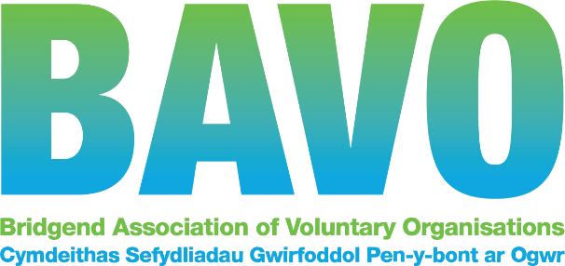

Equal Opportunities Monitoring Form

BAVO is committed to equal opportunities and values diversity. If you choose to complete this form, we want to reassure applicants that this form will not be used at any stage of the recruitment process. The form is separated from the application form immediately on its receipt and is not given to panel members. Any information given on this form will remain confidential and will only be used for monitoring purposes to assess the effectiveness of our equal opportunities and diversity policy.
Post applied for: ____________________________________________________________

Gender: How would you define your gender? Please tick as appropriate:
Male
Female
Other (please state)
Prefer not to say

Age: How would you define your age? Please tick as appropriate:
Under 18
Between 19 – 25
Between 26 – 40
Between 41 - 49
Between 50 - 65
Over 66 +
Prefer not to say

Disability: Do you consider yourself to have a disability? Please tick as appropriate:
Yes |  | No |  | Prefer not to say

Sexual orientation: How would you define your sexual orientation? Please tick as appropriate:
Gay
Lesbian
Heterosexual
Bisexual
Other
Prefer not to say

Ethnic group
To which of these ethnic groups do you consider you belong? Please tick as appropriate:
White
British
English
Irish
Scottish
Welsh
Other White background (please state):
Gypsy /Roma /Traveller community
Mixed heritage
White and Black Caribbean
White and Black African
White and Asian
Other mixed heritage background (please state)
Asian or Asian British
Indian
Pakistani
Bangladeshi
Other Asian background (please state):
Black or Black British
Caribbean
African
Other Black background (please state):
Chinese or other ethnic group
Chinese
Other ethnic group (please state):

Prefer not to say

Religion or belief

Do you have a religion or belief?
Yes |  | No |  | Prefer not to say
If yes, please specify here:

Thank you
If you wish to submit this separately to your application form, please send to dpofficer@bavo.org.uk

