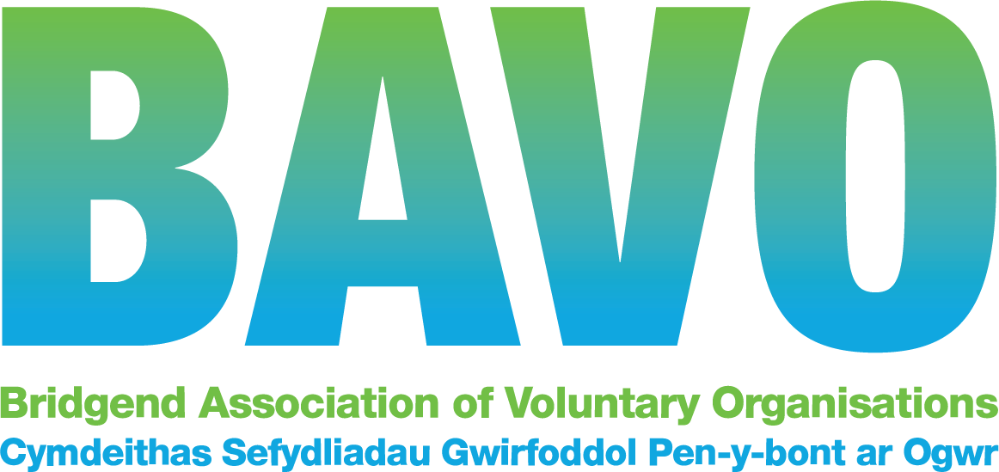

BAVO Trustee Eligibility Form

I declare that I have read the Charity Commission’s automatic disqualification guidance and am EITHER not disqualified from acting as a charity trustee for any of the following reasons OR I have obtained a waiver from the Charity Commission which sets my disqualification aside and have attached a copy to this form.

- You have an unspent conviction for any of the following:

  - an offence involving deception or dishonesty.

  - a terrorism offence to which Part 4 of the Counter-Terrorism Act 2008 applies.

  - an offence under section 13 or 19 of the Terrorism Act 2000.

  - a money laundering offence within the meaning of section 415 of the Proceeds of Crime Act 2002.

  - a bribery offence under sections 1, 2, 6 or 7 of the Bribery Act 2010.

  - an offence of contravening a Commission Order or Direction under section 77 of the Charities Act 2011.

  - an offence of misconduct in public office, perjury or perverting the course of justice.

  - In relation to the above offences, an offence of: attempt, conspiracy, or incitement to commit the offence; aiding, or abetting, counselling or procuring the commission of the offence; or, under Part 2 of the Serious Crime Act 2007 (encouraging or assisting) in relation to the offence.

- You are on the sex offenders register (i.e. subject to notification requirements of Part 2 of the Sexual Offences Act 2003).

- You have an unspent sanction for contempt of court for making, or causing to be made, a false statement or for making, or causing to be made, a false statement in a document verified by a statement of truth.

- You have been found guilty of disobedience to an order or direction of the Commission under section 336(1) of the Charities Act 2011.

- You are a designated person for the purposes of Part 1 of the Terrorist
Asset-Freezing etc. Act 2010, or the Al-Qaida (Asset-Freezing) Regulations 2011.

- You have previously been removed as an officer, agent or employee of a charity by the Charity Commission, the Scottish charity regulator, or the High Court due to misconduct or mismanagement in the administration of the charity.
- You have previously been removed as a trustee of a charity by the Charity Commission, the Scottish charity regulator, or the High Court due to misconduct or mismanagement.

- You have been removed from management or control of anybody under section s34 (5) (e) of the Charities and Trustee Investment (Scotland) Act 2005 (or earlier legislation).

- You are disqualified from being a company director, or have given a disqualification undertaking, and leave has not been granted (as described in section 180 of the Charities Act) for you to act as director of the charity.

- You are currently declared bankrupt (or subject to bankruptcy restrictions or an interim order).

- You have an individual voluntary arrangement (IVA) to pay off debts with creditors.

- You are subject to a moratorium period under a debt relief order, or a debt relief restrictions order, or an interim order.

- You are subject to an order made under section 429(2) of the Insolvency Act 1986 (failure to pay under a County Court Administration Order).

(Please select relevant option *)
I confirm I am not disqualified *
I confirm I have a waiver document that can be presented*

Name:

Signed:

Dated:

Please return (together with Equalities Form) to:
BAVO - 112-113 Commercial Street, Maesteg, CF34 9DL
T: 01656 810400
E: bavo@bavo.org.uk
