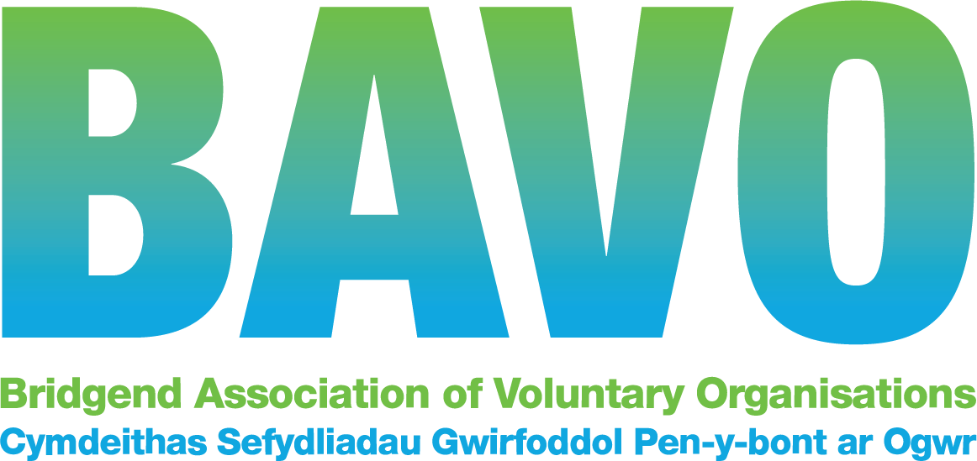

One of the essential requirements for good governance in any organisation is for its trustee board or committee to have a good mixture of skills and experience across the team as a whole.
A good way of checking out what your Board or Committee currently has (and hasn’t /needs) is to undertake a skills audit. There’s a template below; you can adapt it to suit your needs.
You can do this at one of your meetings and it shouldn’t take more than an hour or so. Each member of the Board /Committee can fill in the sheet separately, then put all the results together and find where you are strong and where the team has gaps.
Once you’ve done that, you can work out how to fill the gaps – usually by recruiting one or more new Board/Committee members with the missing skills and/or by existing team members undertaking training in areas where they would like to develop or improve their knowledge and skills, or where support from a BAVO mentor might help
Effective Boards and Committees usually undertake a skills audit every 12 months or so to make sure they’re up to date and well prepared to take their organisation forward.
And remember, when people leave, you need to think about what skills you might be short of and what you need to do to fill the gap!!
TRUSTEE SKILLS AUDIT TEMPLATE AND BOARD EXERCISE

How does it work?

- As a team. review the skills and experience in the list below so you can agree on the different skills, knowledge and experience your Board or Committee needs to have on it. Where an item is not applicable for your organisation, cross it out.

- Add any skill, knowledge or experience that you feel is missing from the list. What does your board/organisation need? Do you have the right mix of skills, knowledge and experience to effectively govern your charity, taking into account its strategic objectives now and in the future?

- Once you’ve done that, each trustee/ committee member then needs to complete the form individually. For all skills, knowledge or experience, decide whether you have a lot of experience in this area, know a bit about it or would like to know more about this. Tick the relevant column.

- Review the forms together as a team. What, if any, key skills/experience/knowledge are missing from the current board? Make a note of them. This will allow you to see what additional skills, knowledge and experience you would like to recruit. You can use the findings of this audit in your trustee recruitment advert or when talking to potential new trustees. You can add it to the role description and advertise on the Volunteer Wales website. It might also form the basis of a learning and development plan with your current board.
Skills, knowledge and experience table for our organisation

Date completed | Experience  Have a lot of experience of this | Understanding  Know a bit about this | Recruitment /Development need Need to recruit a Board member with this and/or learn more about this
Chairing effective meetings
Teamwork and delegation
Strategic planning /
operational planning
Knowledge of the organisation’s operating environment
Knowledge of local community
Knowledge of the sector
Legislation in relation to the organisation’s work
Financial planning

Fundraising /income generation
Finance and accounting
Marketing
Social media
Campaigning
Monitoring and evaluating performance
Governance
Human resources /staff and volunteer management
Information technology
Administration
Conflict resolution
Networking
Customer care
Add your own

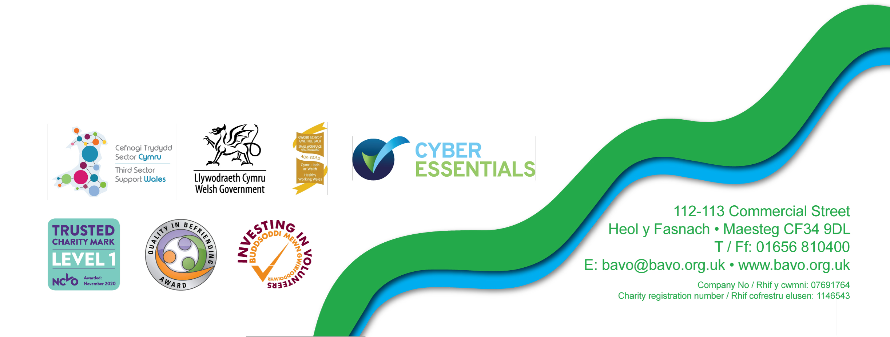
And remember…if it will be helpful, a BAVO staff member can help your Board or Committee work through this exercise; simply contact our Development Team to make arrangements by calling 01656 810400 or E: bavo@bavo.org.uk

