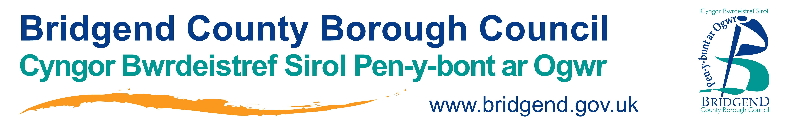

Cymorth Cyntaf
19 NEU 26 Ionawr NEU 2, 9 NEU 16 Chwefor 2021
Deilliannau Dysgu
Rolau a chyfrifoldebau y sawl sy'n rhoi cymorth cyntaf mewn argyfwng
Asesu digwyddiad
Rheoli anafusion nad ydynt yn ymateb
Adfywio cardio-pwlmonaidd
Ystum adfer
Tagu
Ffitiau
Sioc
Clwyfau a Gwaedu
Mân anafiadau (Cwtau, crafiadau a chleisiau)
Mân losgiadau a sgaldiadau.

Hwylusydd: Lifeline
Cydlynydd: David McManus
Lleoliadau: Nantyffyllon RFC
Amseroedd: 9:15am cyrraedd i ddechrau am 9:30am –
4:30pm gorffen

Eich enw cyswllt archebu ar gyfer y cwrs yw: SCWDP  Tîm Datblygu'r Gweithlu Gofal Cymdeithasol  Cyngor Bwrdeistref Sirol Pen-y-bont ar Ogwr  Lefel 2 Swyddfeydd Dinesig | Stryd yr Angel | Pen-y-bont ar Ogwr |  CF31 4WB  Rhif ffôn: (01656) 643228  E-bost: SCWDP@bridgend.gov.uk | Gwybodaeth i Gynrychiolwyr  Nodwch:  - Ni ddarperir cinio.  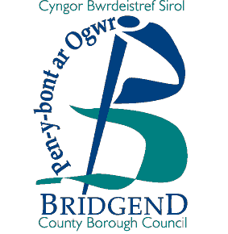

First Aid
19 or 26 January or 2, 9 or 16 February 2021

Learning Outcomes
The roles and responsibilities of an emergency first aider
Assessing an incident
Managing an unresponsive casualty
CPR
Recovery position
Choking
Seizures
Shock
Wound and Bleeding
Minor injuries (Cuts grazes and bruises)
Minor burns and scalds.
NB Any member of staff who is unable to work at ground level on the day to complete the recovery position and CPR parts of this course will not be able to take part on the course and will regrettably be asked to leave.

Facilitator: Lifeline
Coordinator: David McManus
Venues: Nantyffyllon RFC
Times: 9:15am arrival for 9:30am start –
4:30pm finish

Your course booking contact is: SCWDP  Social Care Workforce Development Team  Bridgend County Borough Council  Level 2 Civic Offices | Angel Street | Bridgend |  CF31 4WB  Phone: (01656) 643228  Email: SCWDP@bridgend.gov.uk | Delegate Information  Please note:  - Lunch will not be provided

