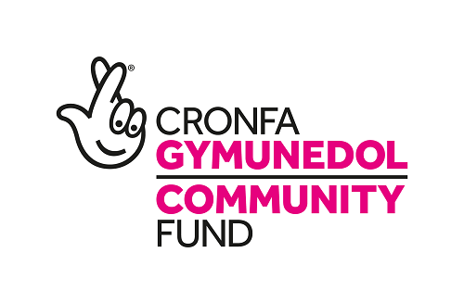
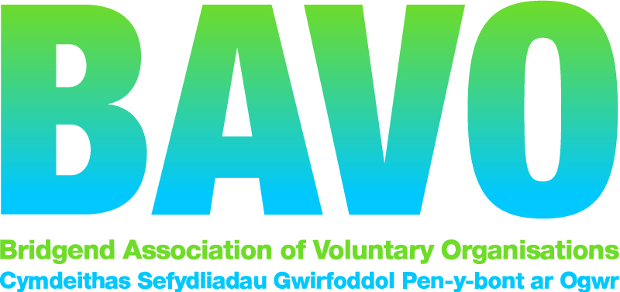
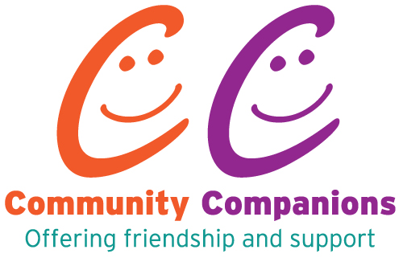

Telephone Befriending Referral Form
BAVO’s Community Companions befriending scheme is for people who are isolated in Bridgend County Borough. Please be aware that our volunteer befrienders are unable to provide any medical care, personal care or domestic support.
Please return this form to:
Community Companions, Bridgend Association of Voluntary Organisations,
112-113 Commercial Street, Maesteg, CF34 9DL
or email to: tracybeall@bavo.org.uk

About the person you are referring……….
Title: Mr /Mrs /Miss …………………….
First name: ……………………………………Last name: ………………………………….
Address: ……………………………………………………………………………………………
……………………………………………………………………………………………
Postcode: ………………………………….
Telephone number: ……………………………………………
Mobile number: ………………………………………………….
Date of birth: ………………………………Age:…………………….

Are there any communication/mobility or health issues that we need to be aware of? e.g. Arthritis, hearing impairment, partially sighted, registered blind, breathing problems, heart problems, communication problems, depression, use of walking aids i.e. sticks, frames, wheelchair.
If yes, please specify:
……………………………………………………………………………………………………………
……………………………………………………………………………………………………………
……………………………………………………………………………………………………………

About the person’s hobbies and interests (details are really helpful)
……………………………………………………………………………………………………………..
……………………………………………………………………………………………………………..
……………………………………………………………………………………………………………..
…………………………………………………………………………………………………………….

Why does this person require befriending?
……………………………………………………………………………………………………………..
……………………………………………………………………………………………………………
……………………………………………………………………………………………………………..
……………………………………………………………………………………………………………..

Does the person have a risk assessment in place? Yes/No
If yes, we must have access to this.

Does the person have a preference on the gender of the volunteer? Yes / No
If yes please state which…………………………………………………………………..

About you, the referrer……
Your name: ………………………………………………Agency: …………………………………
Address: ……………………………………………………………………………………………
……………………………………………………………………………………………
Postcode: ……………………………….
Telephone number(s): ……………………………………………
Email: ………………………………………………….

Has the person you are referring agreed to be referred and receive befriending support?
Yes No

BAVO takes your privacy seriously, and the Community Companions Project operates in line with GDPR (General Data Protection Regulation) which came into force on 25 May 2018. Our lawful basis for processing your personal data is legitimate interest, we will use it to (i) register you as a new beneficiary, (ii) to manage our relationship with you and get in touch when needed, (iii) provide anonymised statistics to our funder, The Big Lottery Fund. Your personal data will be stored securely until the project ends.
Referrer’s signature: …………………………………….. Date: ………………..

Community Companions – FOR OFFICE USE ONLY
Initial action taken by visiting support worker
………………………………………………………………………………………….
Befriendee no: ………………
Signature of Project Manager………………………………… Date……………………

