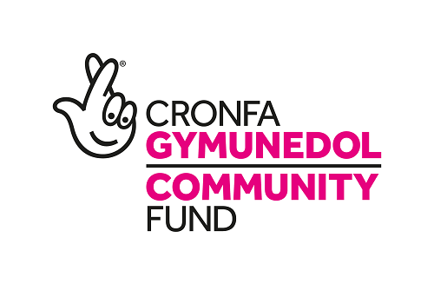
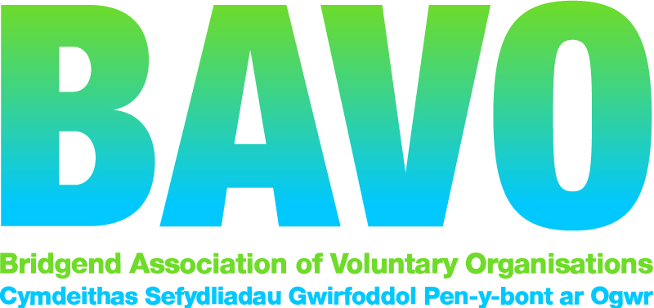
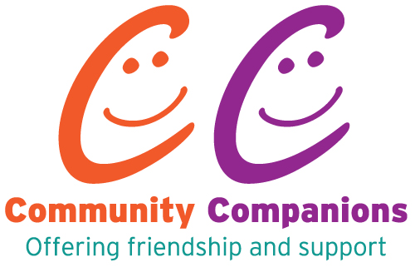

Telephone Befriending Project Volunteer Application Form

- Full name:
Postcode:
Mobile phone:
Landline:
DOB:
Email:

2. What are your hobbies and interests?

3. Do you have any preferences about the person you will befriend?
(e.g. age, gender etc.)
Age: Yes (please specify) No
Gender: Yes No
Other:

4. What times and / or days can you volunteer?
(Please complete as many or as few as applicable)
 | Morning | Afternoon | Evening
Monday
Tuesday
Wednesday
Thursday
Friday
Saturday
Sunday

5. How did you hear about the Community Companions Telephone Befriending Project?

6. Do you volunteer with any other agency? Yes No
If yes, please tell us which agency

7. Are you a Welsh Speaker? Yes No
8. Please provide us with a referee, for example your employer or someone who knows you well who is happy to give us with a reference for you via email
Referee 1
Full Name:
Email address:
Post Code:
Tel No:
Their relationship to you:

9. Any other information you would like us to know about?
GDPR and your information
Your information will be kept by BAVO as a part of the Community Companions Project. We will keep your information to match you appropriately to a beneficiary and to be able to contact you in regard to your role as a befriender. We will only keep your information for the duration of the project. You can request the information we have on you at any time. You have the right to be removed from our database. Please sign below to consent to us using your details in this manner.
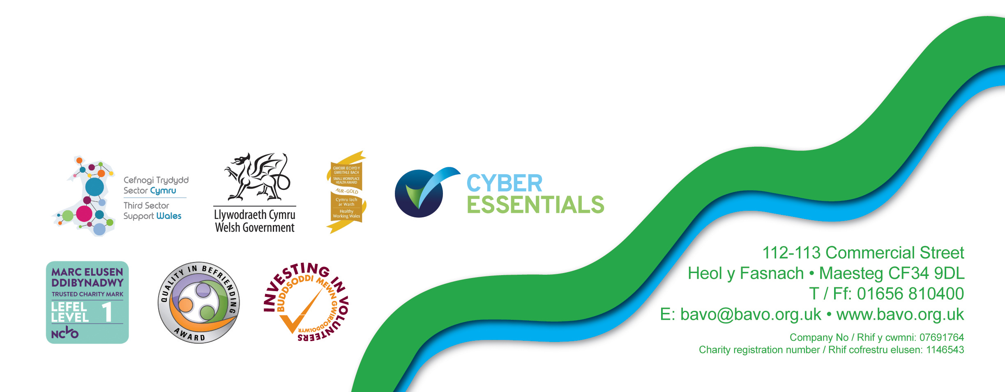
Your Signature:
Date:
Please return this form to:
Community Companions, Bridgend Association of Voluntary Organisations,
112-113 Commercial Street, Maesteg, CF34 9DL
or email to: tracybeall@bavo.org.uk

