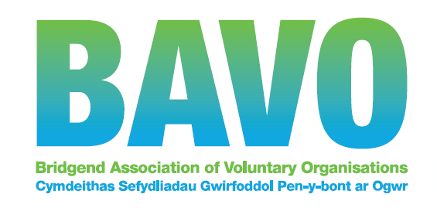

BAVO free online event booking form
Please submit one form per person

Event title | Event date

Participants name:

Organisation: | Position/role
Address:

Postcode:

Telephone: | Mobile:
Participants Email:

If you discover in advance of the event that you will not be able to attend please let us know as soon as possible as we spend a great deal of time planning events very carefully and in detail to accommodate the number of participants we expect.
Please contact us in advance if you have specific additional needs that would make it difficult for you to attend e.g. carer’s cover. We will endeavour to meet your needs.

I have specific additional requirements as follows:

Please help us to ensure that the content of the event suits your needs by telling us up to three things you want from the event:
1

2

3

My level of experience in this topic is:
Lots | Some | A little | None

General Data Protection Regulation - GDPR
For participants from BAVO member groups (Full and Associate):
We will process your data for the purposes of contacting you in relation to your event booking. This will be processed on the basis of legitimate interest. We will only keep your contact information for the period of BAVO membership. If your group’s membership lapses all contact information will be deleted within 12 months, unless your organisation has received services or grant funding from us. See our full Privacy Notice on our website at www.bavo.org.uk

For participants who are not from BAVO member groups:
We will process your personal data to:
- register you as a training participant and send you registration updates;
- provide anonymised statistics to our funder.
Your personal data will be stored securely for six years for auditing purposes. For full information, including your rights as a data subject, please see our Privacy Notice at: www.bavo.org.uk

For all participants:
We may want to contact you in future regarding this or other training or events.
In order to do so we need your consent.
I consent to receiving information by Post Telephone Email

Would you like future correspondence in the medium of: (please tick) English Welsh

Please note: If you do not give consent, you will not receive further information from us which may be relevant to this event/training, or other event/training opportunities.

BAVO is a member of Third Sector Support Wales (TSSW) which is a partnership between Wales County Voluntary Councils (CVCs) and Wales Council for Voluntary Action (WCVA). We use a secure shared database where we hold third sector contact details. If you have any query about the use we make of your data, please refer to our Full GDPR Privacy Notice on our website at www.bavo.org.uk

I have read and agree to the terms and conditions: | Participant’s signature: (we will accept your typed name as your signature when you email this form back to us)  DATA PROTECTION - BAVO requires the permission of the participant in order to store their personal contact details, so please ensure this form is completed by the participant. | Date:
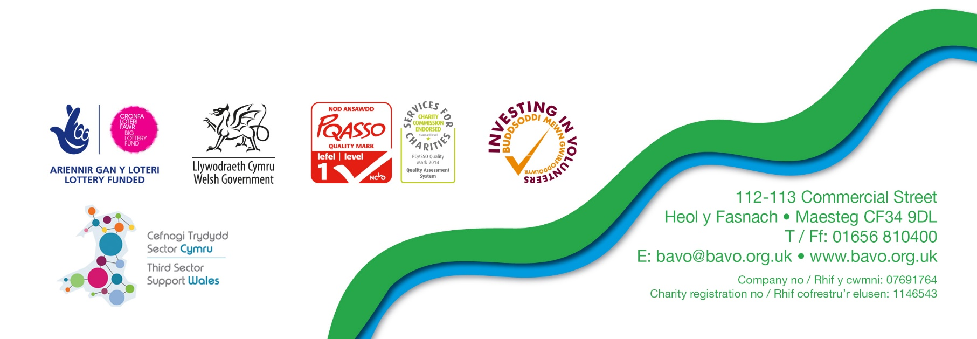
Please return to: bavo@bavo.org.uk

16.07.20 © BAVO

