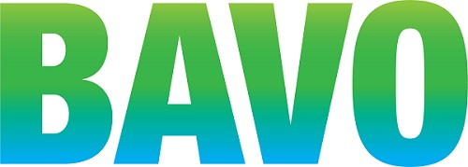
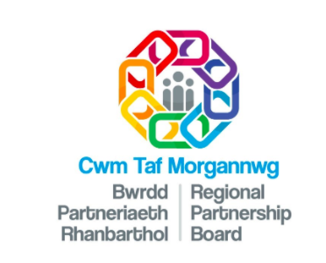
ICF: COMMUNITY Wellbeing GRANT SCHEME 2020-21
Please ensure that your organisation is eligible based on the information above and read the background Information and guidance notes before applying.

If you need help or require an alternative format, please contact us.
- Contact Details
- Organisation name
Address

Post Code
Contact name
Phone
Email
Website
b) When was your group established?
c) Is the organisation registered as a Charity, CIO, CIC or company? Yes / No
If yes, please provide the relevant registration numbers:
d) How many people work with your organisation?

Trustees / Board / Committee members
Volunteers
Paid staff
Beneficiaries (approximately)
- Your Project
Where in Bridgend County will the project take place or be targeting?
Is the project new to your organisation? | ☐ Yes  ☐ No
Is a similar project currently being delivered in Cwm Taf Morgannwg area or elsewhere? | ☐ Yes (tell us below why we should consider your application)  ☐ No  ☐ Don’t know

Which beneficiary groups will your project support: (please tick).

(Revenue funding can include volunteer expenses, project running costs, salaries, marketing materials etc.)

ICF is not continuation funding for existing projects.

Revenue

☐ Young People with learning disabilities
☐ Children with complex needs and their families and/or carers
☐ Children and young people with, or at risk of, poor emotional wellbeing
☐ Young carers

Main criteria your project is meeting:(please tick)
☐ Combat the impact of loneliness and isolation
☐ Prevent unnecessary access to statutory services
☐ Support hospital discharge
☐ Support beneficiary groups to maintain their health, wellbeing and independence
☐ Support the emotional wellbeing of children and young people

a) What evidence do you have that there is a need and support for this work, Have children/young people helped inform this project? (max 300 words)?

b) Describe your project: tell us what you want to do and who you will help (Max 500 words)

c) What difference will this project make for the children/young people you want to help, and how many so you anticipate helping? (refer to the the aims of the fund)

d) Please list no more than three key differences (outcomes) you hope make to the lives/wellbeing of these young people?

e) How will you ensure that the project is open (equality) and safe for children and young people?

f) How will you know your project has been successful, what do you intend to do to find this out?

g) Do your staff have up to date DBS checks (where required?) Yes/No
Are staff trained in safeguarding ?

(please state any qualifications/registrations)

h) Does your organisation have an accredited quality mark/standard? If so please tell us.

j) Can your project be delivered by 31 March 2021? Yes / No
NB. If you cannot complete the project in this time, it will be ineligible.
k) Will services be available through the Welsh language?

Face to face Yes/ No

Written Information Yes/ No

Electronic Information Yes / No

If the answer for any of the above is ‘No’, please state the reason below:

If you do not have a welsh language policy you will be required to work with BAVO to achieve one. Please tell us if you have a policy?

3. Project Costs
- Item of expenditure (please be detailed) |  | Cost (£)
e.g. 1 x worker (18.5 hrs per week at salary scale £_), on-costs, pension
Total Project Cost
Total grant requested
Costs covered from other source(s)
b) If you have indicated that some costs will be covered by other sources, please complete this table
Source Amount Confirmed?

c) If we are unable to provide the amount you have requested, would you be able to deliver the project with reduced funding? Yes / No
d) Do you plan to continue the project beyond the end of any funding awarded? If so, how will you fund this?

e) Are you VAT registered? If yes, please state your VAT registration number:

Please note that if you are VAT registered then VAT will be non-claimable through this grant. Please ensure you do not include VAT in the costs.
If you are not VAT registered then please ensure that costs are inclusive of VAT.

DECLARATION
I confirm on behalf of my group that I am authorised to sign this declaration and that to the best of my knowledge all information within this application is accurate. As a group, we hold the required consents, insurances, safeguarding measures, ownership/leasing documents in order to carry out the activities stated in this application.

I understand that the grant must be spent for the purpose for which it is awarded and within the given timeframe otherwise it may be subject to repayment in part or in whole.

I understand that the panel’s decision is final and there is no appeals process. I understand that BAVO (for the administration of this scheme) may collect further information in support of this application at any stage of the process and that any offer is made on the basis of agreement with the terms and conditions provided at the offer stage.

By submitting this application form, I give consent to the information being kept on file for administration and monitoring purposes for the duration of the grant process. As part of the decision-making process, applications and supporting documents will be shared with partners.

Our privacy policy can be found online with the grant application documents.
 | Role:
Signature on behalf of applicant organisation | Date:

Please use this checklist to ensure you are sending a complete application:

◻ All questions have been answered
◻ The application form has been signed by an authorised individual
◻ Guidance notes have been read and understood
◻ You have kept a copy of the application form for future reference

Completed applications to be sent by email to
grantsadmin@bavo.org.uk
Closing date: 5pm on 9th October 2020

Please note applications should receive an acknowledgement reference number within 24 hours of receipt. If you do not receive this, you should call 01656 810400 to check your application has been received.

