

Development Support Form

|  |
| --- |
| Before you complete and return this form, have you looked on our website for the information you may be looking for?  Our information sheets on getting started, running your organisation, trustees and governance etc. can be found at [www.bavo.org.uk/advice-and-guidance-fact-sheets](http://www.bavo.org.uk/advice-and-guidance-fact-sheets)  Looking for funding for your project or organisation? Visit [www.bavo.org.uk/find-funding](http://www.bavo.org.uk/find-funding) |

Name of group or organisation: ……………………………………………………………………

Contact name:………………………………………………….. Position/role:……………………….:

Address:………………………………………………………………………………………………………

…………………………………………………………………… Postcode: …………………………..

Contact telephone number/s: …………………………………………………………………………...

Alternative contact: …………………………………………… Mobile:………………………………..

Email:………………………………………………………………………………………………………….

Website: ……………………………..............................................................

Are you a member of BAVO? Yes No Yes pending governing document

|  |
| --- |
| **What does your organisation do or want to do?** |

|  |
| --- |
| Please tell us what you would like help with: |

Do you employ staff? Yes 🞎 No 🞎 If yes, how many? ………..

**Number of volunteers (including trustees): ……………………**

**Is your organisation: (please tick) Local Regional National**

Do you have a governing document? Yes 🞎 No 🞎

**Do you have a bank account in the group’s name? Yes 🞎 No 🞎**

How much funding to you receive into your account in a year? (include all income)

(please tick one)

Under £5,000  £5,001 - £10,000  £10,001 - £25,000 

£25,001 - £50,000  More than £50,000 

Are you a registered charity? Yes 🞎 Charity Number? ……………… No 🞎

**What are your main sources of funding?**

Own fundraising activities 🞎 Member subs 🞎 Events 🞎 Grants **🞎**  Trading **🞎**   
  
Other **🞎 ………………….**

Would you like an appointment or telephone call back Yes 🞎 No 🞎

**PLEASE NOTE:**

If you are not a member of BAVO, you will be offered **up to three hours** initial support. Membership is free and offers a range of benefits and will enable you to access further support. Forms are available online by visiting [www.bavo.org.uk/bavo-membership](http://www.bavo.org.uk/bavo-membership) or contacting BAVO,  
T: 01656 810400 or E: [bavo@bavo.org.uk](mailto:bavo@bavo.org.uk)

We may want to contact you in future about events and other opportunities and information relevant to the voluntary and community groups, such as networks, funding opportunities, training, e-briefings and newsletters.

In order to do so we need your consent. If you would like to continue to receive our information, please consent by telling us your preferred contact method:

**I consent to receiving information by : Post Telephone Email**

**Please note:** **If you do not give consent, you will not receive further information from us other than membership information (as above).**

Would you like future correspondence in the medium of: (please tick) English Welsh

**Important information**

**General Data Protection Regulation (GDPR)**

For associate and full members, we will process your data for the purposes of contacting you in relation to your BAVO membership and voting rights, including notice of our AGM and to receive our annual impact report during the period of membership. This will be processed on the basis of legitimate interest.

We will only keep your contact information for the period of membership .If your membership lapses, all contact information will be deleted within 12 months, unless your organisation has received services or grant funding from us. On the basis of legal and legitimate interest, we will need to keep that information on archive for audit purposes, this is usually six years.

BAVO is a member of Third Sector Support Wales (TSSW) which is a partnership between Wales County Voluntary Councils (CVCs) and Wales Council for Voluntary Action (WCVA). We use a secure shared database where we hold third sector contact details. **If you have any query about the use we make of your data, please refer to our Full GDPR Privacy Notice on our website at** [**www.bavo.org.uk/what-we-do**](http://www.bavo.org.uk/what-we-do)

If you want your organisation’s details to be published in the national online third sector database so that your organisation may be easily found and promoted free of charge, please visit [www.infoengine.wales](http://www.infoengine.wales)

**Signed**………………………………………. **Date**…………

Thank you for taking the time to fill in this form.   
We aim to contact you with 10 working days of receipt.

Please return to:

BAVO, 112-113 Commercial Street, Maesteg CF34 9DL

or email: [bavo@bavo.org.uk](mailto:bavo@bavo.org.uk)

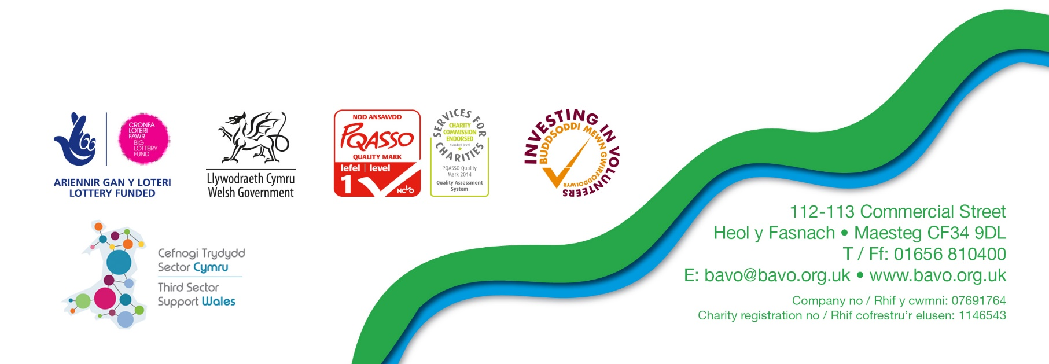Information downloads are also available on our website [www.bavo.org.uk](http://www.bavo.org.uk)

30.06.20 © BAVO