

BAVO membership application form

Name of organisation:
Contact name:
(Please remember to update us with any changes to your primary contact)
Address: | Postcode:
Telephone no:
Mobile no:
Website:
Email:
Officers: Chair:
Secretary:
Treasurer:
Other:
Does your organisation have a governing document?  (Please forward your governing document when returning your completed membership form) | Yes □ No □  (If your answer is NO, we will ask your organisation to work with us on adopting a simple governing document)
Is your organisation a registered charity?  CIO? CIC? Company? | Yes □ No □  (Please give registered numbers)
Aims of the organisation:

Main activities / services:

What was your income level last year? (Please tick) Up to £5,000

Up to £10,000 Up to £25,000 Over £25,000

Is your management committee based in Bridgend County Borough? | Yes □ No □
Is your organisation of benefit ONLY to Bridgend County Borough? | Yes □ No □
If No, please state what area your work covers

Continued overleaf …………….
BAVO’s aim is to include a variety of interest groups among the membership. Please circle UP TO THREE CATEGORIES below that are relevant to your work:

Addiction support |  | Employment and skills
Advocacy, advice and welfare |  | Public services
BME Communities |  | Health and social care
Children and families |  | Housing and homelessness
Arts, culture and heritage |  | Mental health
Communities and community centres |  | Older people
Disability/Impairment |  | Sport and leisure
Education and learning |  | Young people
Environmental |  | Geographic area: please state:

If you want your organisation’s details to be published in our online third sector database so that your organisation may be easily found and promoted free of charge, please visit www.infoengine.wales

For associate and full members, we will process your data for the purposes of contacting you in relation to your BAVO membership and voting rights including notice of our AGM and to receive our annual report during the period of membership. This will be processed on the basis of legitimate interest.

We will only keep your contact information for the period of membership. If your membership lapses all contact information will be deleted within 12 months, unless your organisation has received services or grant funding from us. On the basis of legal and legitimate interest, we will need to keep that information on archive for audit purposes this is usually six years.

However, we may want to contact you in future about events and other opportunities and information relevant to the voluntary and community groups, such as networks, funding opportunities, training, e-briefings and newsletters. In order to do so we need your consent. If you would like to continue to receive our information, please consent by telling us your preferred contact method:

I consent to receiving information by Post Telephone Email

Would you like future correspondence in the medium of: (please tick) English Welsh

Please note: If you do not give consent, you will not receive further information from us other than membership information (as above).

BAVO is a member of Third Sector Support Wales (TSSW) which is a partnership between Wales County Voluntary Councils (CVCs) and Wales Council for Voluntary Action (WCVA). We use a secure shared database where we hold third sector contact details. If you have any query about the use we make of your data, please refer to the attached Full Privacy Statement which can also found by visiting www.bavo.org.uk

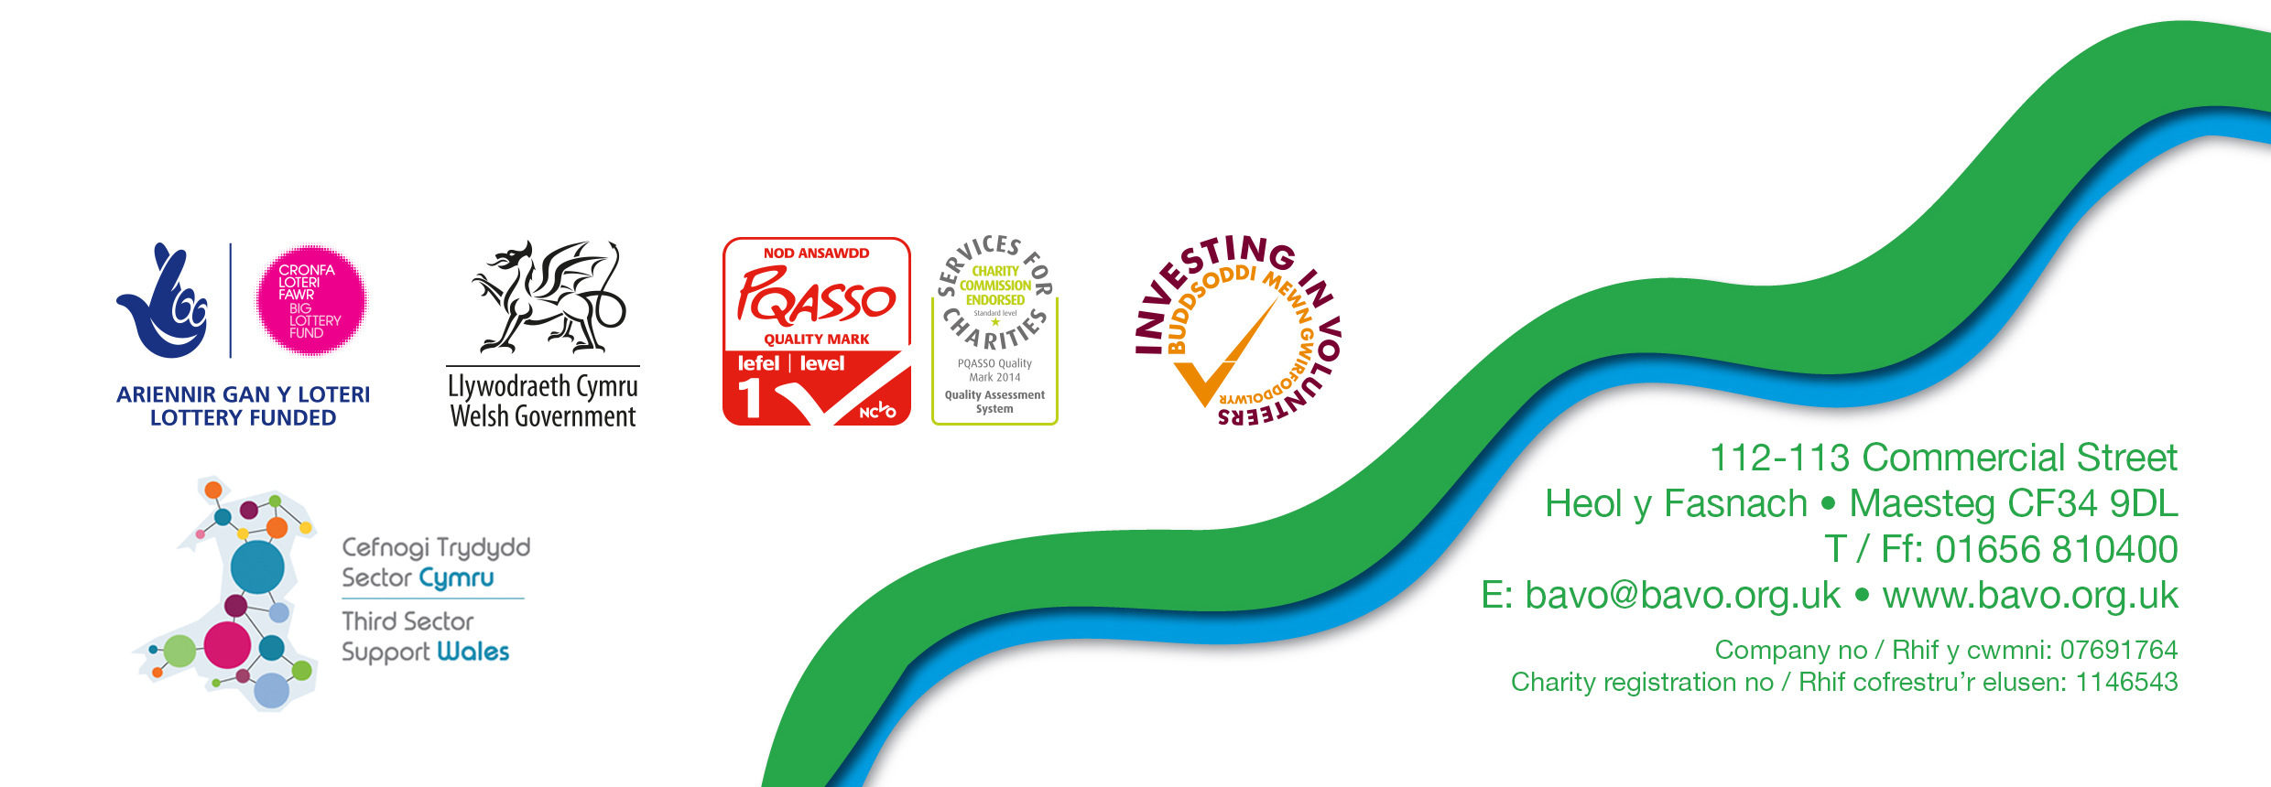
Signed …………………………………Position………………………………………….Date ………….

07.02.2020 © BAVO



